**VALIDATING PHONE NUMBER**

Piyush Garg Shanky Gupta

2K18CSUN01072 2K18CSUN01083

CODE:

# Number is valid if it has 13 digits and begins with 1 or 2

print('Enter the Phone Numbers to check whether they are Valid Or Not')

print('If u want to exit press done')

while True:

phn=input('Enter a number:')

if phn=='Done' or phn=='done' or phn=='DONE':

break

try:

phne=int(phn)

except:

print('Invalid Input')

continue

phne=str(phn)

if(len(phne)==13):

if (phne[0]=='1' or phne[0]=='2'):

print('Valid')

else:

print('Invalid')

else:

print('Invalid')

print('THANK YOU')

OUTPUT:

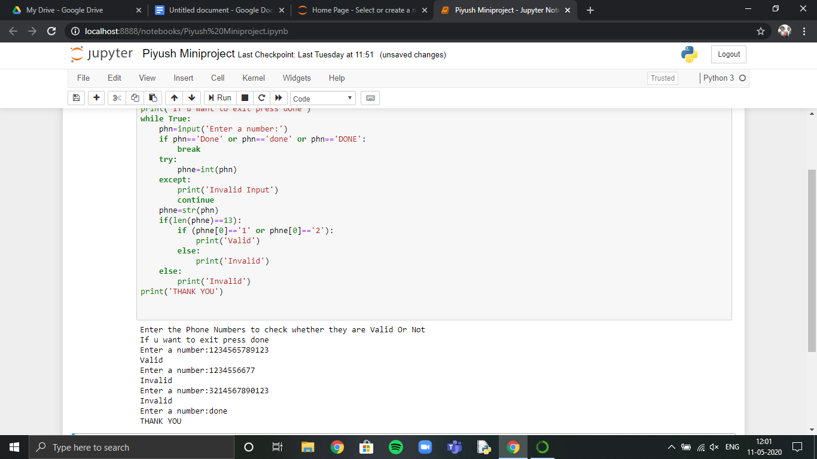

VIDEO LINK:

[Video Link](https://drive.google.com/open?id=1ST3JSPu8xC6eu0Sq0mjgGwRE0helKmT7)